Chapter 15, Solution 10.

- By taking the derivative in the time domain,
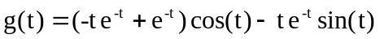

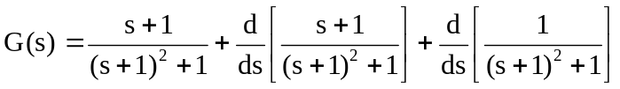

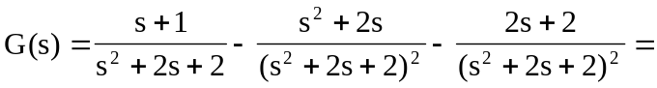

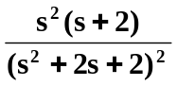

- By applying the time differentiation property,
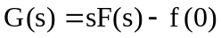
where  